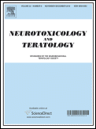

CALL FOR PAPERS:

SPECIAL ISSUE OF NEUROTOXICOLOGY AND TERATOLOGY
DEVELOPMENTAL NEUROTOXICITY ASSOCIATED WITH PEDIATRIC GENERAL ANESTHESIA: PRECLINICAL FINDINGS

Research into the impacts of pediatric general anesthesia on the developing brain has garnered significant attention and concern in recent years. This important work has produced new insights into the possible developmental origins of adult diseases. Accordingly, Neurotoxicology and Teratology is organizing a special issue of the journal devoted to capturing the current status of the science including information on the effects of specific agents, doses, durations and frequencies of general anesthesia that occur during critical periods of brain development. The theme of the issue will be “Developmental Neurotoxicity Associated with Pediatric General Anesthesia: Preclinical Findings” and it will be co-edited by Drs. Merle G. Paule of the FDA’s National Center for Toxicological Research and Vesna Jevtovic-Todorovic of the University of Colorado School of Medicine. Our intention is to capture recent observations from well-controlled studies in animal models, and to review and synthesize these findings into a definitive description of the state of the science today.

We are inviting interested experts in this area to contribute a paper to this issue. You should only submit articles that relate directly to the Special Issue topic; you will be expected to provide an overview of the area about which you will be writing along with relevant aspects of your original research. All submissions to this special issue will be fully peer-reviewed and, because Neurotoxicology and Teratology is abstracted and indexed in BIOSIS, Current Contents/Life Sciences, EMBASE, EMBiology, ETOH, Elsevier BIOBASE, MEDLINE®, Science Citation Index, and Scopus, its contents will be available through typical search engines of the medical literature (e.g., PubMed). The Special Issue will also be circulated to all subscribers of the journal and be accessible via ScienceDirect.
To be considered for inclusion in this Special Issue, please submit your manuscript to Neurotoxicology and Teratology by July 1, 2016, via the electronic submission system at http://ees.elsevier.com/ntt/. Manuscripts should be assigned to the category “SI: Ped Anesthetics” at the beginning of the submission process and a cover letter to the Editor should also specify that the submission is targeted for this issue. Further information about the journal can also be found at that website.
We hope that you will consider this invitation seriously and submit your best work to this issue. Recent trends in scientific publication indicate that articles that appear in special issues receive a great deal of attention and we hope that you will take advantage of this opportunity.

Vesna Jevtovic-Todorovic, MD, PhD, MBA
Merle G. Paule, Ph.D., Fellow ATS Co-Editor Pediatric Anesthesia Special Issue
Co-editor, Pediatric Anesthesia Special Issue Neurotoxicology and Teratology
Neurotoxicology and Teratology Professor and Chair, Department of anesthesiology
Director, Division of Neurotoxicology University of Colorado School of Medicine
National Center for Toxicological Research US FDA vensa.jevtovic-todorovic@ucdenver.edu
merle.paule@fda.hhs.gov

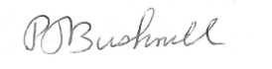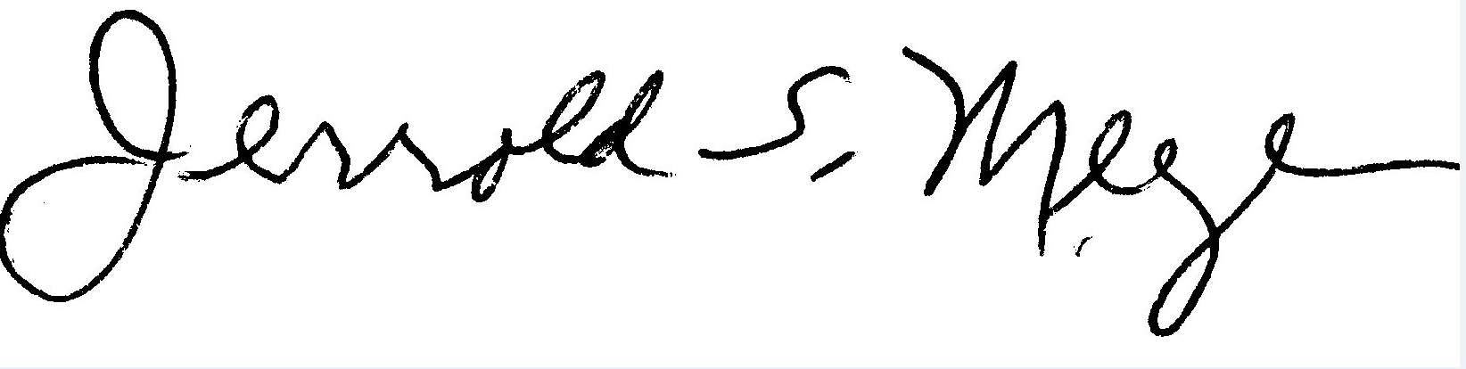
Philip J. Bushnell, Ph.D. Jerrold S. Meyer, Ph.D.
Editor-in-Chief Special Issues Editor
Neurotoxicology and Teratology Neurotoxicology and Teratology
ntt.pjb.gmail.com jmeyer@psych.umass.edu

