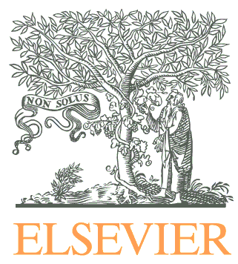
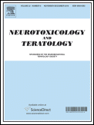

CALL FOR PAPERS:
SPECIAL ISSUE OF NEUROTOXICOLOGY AND TERATOLOGY

Co-use of Tobacco and Marijuana during Pregnancy:
Impact on Nervous System Development

Co-use of tobacco and marijuana is increasingly common, and there is evidence that co-users are more likely to become dependent than individuals who use only one of these substances. Thus, co-using women who become pregnant may find it more difficult to reduce or quit using tobacco and marijuana during pregnancy, resulting in greater fetal exposure across all three trimesters. It is also possible that the use of these substances in tandem during gestation may have a greater impact on development than the use of either substance in isolation. Accordingly, Neurotoxicology and Teratology (NTT) is organizing a Special Issue of the journal devoted to capturing the current status of the field. The issue will be entitled “Co-Use of Tobacco and Marijuana during Pregnancy: Impact on Development of the Nervous System” and will be co-edited by Drs. Natacha De Genna of the University of Pittsburgh School of Medicine, Rina Eiden of the State University of New York at Buffalo, and Laura Stroud of Brown Medical School/The Miriam Hospital (Guest Editors). Papers should deal with exposure to tobacco and marijuana during early development (prenatal through neonatal), and focus on aspects of development of the nervous system in offspring, including behavior, physiology, health, and mechanisms. Of particular interest are studies with prospective measurement of multiple substances at more than one time point during pregnancy.

Submissions may include:
- Primary research reports or critical reviews of the literature
- Prospective/retrospective human studies
- Empirical in vivo or in vitro studies using laboratory animals or cell culture systems

Sample topics might include:
- The effects of co-exposure to tobacco and pregnancy on offspring growth, behavior, or health
- Animal models of the impact of prenatal or neonatal nicotine and marijuana co-exposure on offspring brain and/or behavioral development
- Animal models comparing the impact of prenatal or neonatal nicotine and prenatal or neonatal marijuana on offspring brain and/or behavioral development
- Maternal patterns of co-use of tobacco and marijuana during and after pregnancy
- Co-use during pregnancy comparing states or countries with legal recreational marijuana, medical marijuana, and no marijuana legalization
- Potential mechanisms of nicotine and cannabinoid interaction within the developing brain

All submissions to this Special Issue will be fully peer-reviewed and, because Neurotoxicology and Teratology is abstracted and indexed in BIOSIS, Current Contents/Life Sciences, EMBASE, EMBiology, ETOH, Elsevier BIOBASE, MEDLINE®, Science Citation Index, and Scopus, its contents will be available through typical search engines of the medical literature (e.g., PubMed). The Special Issue will also be circulated to all subscribers of the journal and be accessible via ScienceDirect.

To be considered for this Special Issue, please submit a brief description of the proposed topic to Dr. Natacha De Genna at degennan@pitt.edu no later than Friday September 30th.

Please submit your manuscript to Neurotoxicology and Teratology, via the electronic submission system at https://www.evise.com/profile/#/NTT/login. Manuscripts should be designated for the “Co-Exposure SI” in the system, and the cover letter should also specify that the submission is targeted for this issue. Deadline for full submission of manuscript: December 31st. Target publication date for the Special Issue is July 2018.

Please do not hesitate to contact any one of us if you have any questions about a possible submission. We hope that you will consider this invitation seriously and submit your best work to this issue. Recent trends in scientific publication indicate that articles that appear in Special Issues receive a great deal of attention, and we hope that you will take advantage of this opportunity.

With kind regards,

Philip Bushnell, Editor-in-Chief (ntt.pjb@gmail.com)
Gale A. Richardson, Section Editor (gar@pitt.edu)
Natacha De Genna, Guest Editor (degennan@pitt.edu)
Neurotoxicology and Teratology

